SMRITI KUMARI  PRIMARY TEACHER APPLICANT  East Ashok Nagar, Road No. 14B, Kankarbagh, Patna - 20 • 9065452427 • viskarmamuskaan@gmail.com | 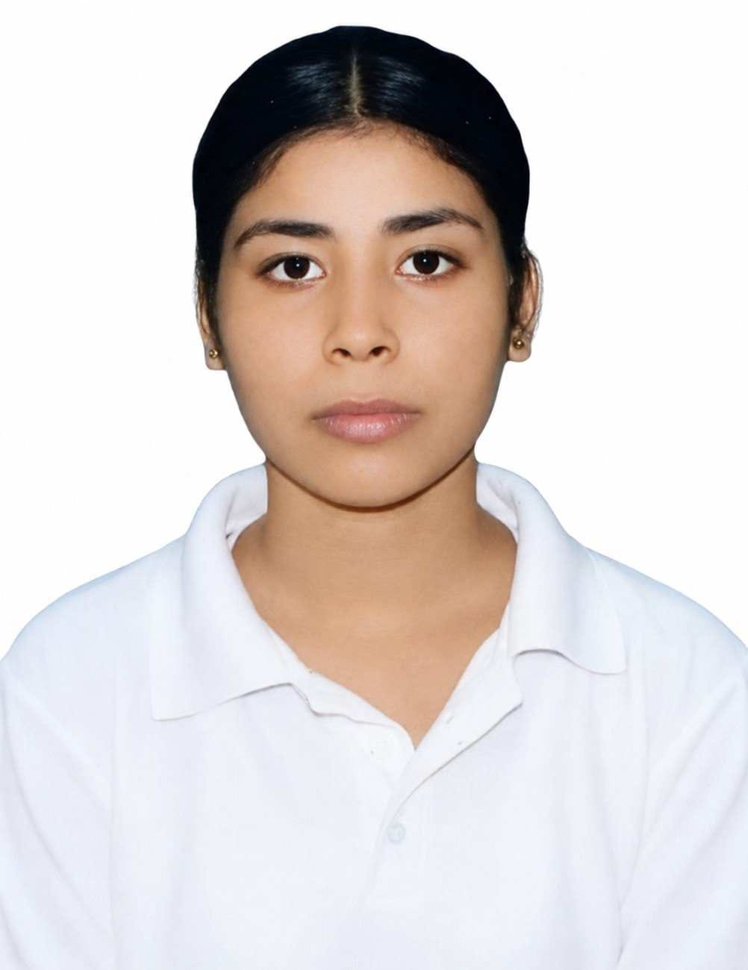
CAREER OBJECTIVE
To begin my career as a Primary Teacher in a reputed school where I can use my teaching skills, patience and subject knowledge to create a positive and engaging learning environment for children, while continuing to grow professionally.

TEACHING EXPERIENCE
Home Tutor — Private Home Tuition
• Provide academic guidance and individual support to students.
• Help with homework, revision and exam preparation.
• Explain concepts clearly according to students' learning needs.
• Monitor progress and encourage students to learn confidently.

EDUCATIONAL QUALIFICATION
Qualification | Institution | Session / Year
B.Ed. | Himalaya Teacher Training College | 2026–2028 (Pursuing)
M.Com. | Nalanda Open University | 2025–2027 (Pursuing)
B.Com. (Hons.) | Sri Arvind Mahila College | 2021–2024

KEY SKILLS
• Patient and student-friendly teaching approach
• Simple and clear explanation of concepts
• Interactive classroom communication
• Ability to encourage student participation
• Basic Computer Skills
• Hindi & English Typing
• Adaptability

CERTIFICATION
Financial Literacy Program – “Kona Kona Shiksha”
Kotak Securities & NISM • February 2023

LANGUAGES
Hindi • English

PREFERRED POSITION
Primary Teacher / Class Teacher

